# Installing TRADEData API and UI Package

## Prerequisites

To build the solution you must install the WIX, currently the 3.10 version is used.  
<http://wixtoolset.org/>

Once it is installed, open the solution file UsersUI.sln and find and expand Setup folder.   
  
Inside of it:

Check setup projects references, update them if needed as they point to WiX installation folder.   
Open the WiXProduct project’s properties, choose Build Events tab:

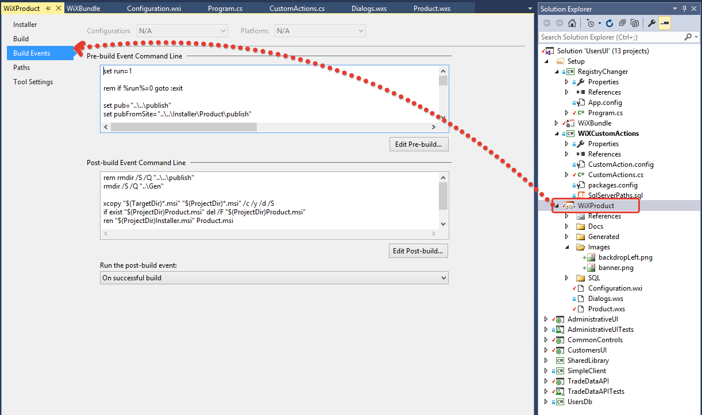

Open pre-build event, check heat.exe and msbuild.exe paths and update them if needed, other paths are relative and should be fine.  
  
In this event I publish the sites to a temporary folder and generate a list of files required for installation package.  
Generated content goes to the files in the folder “Generated”  
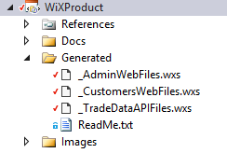

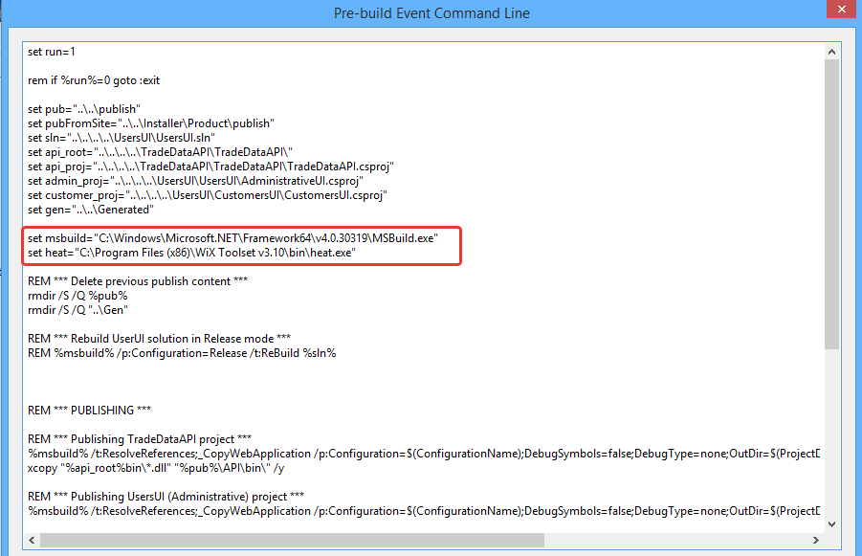

## Build setup executable

To update SQL scripts see them in the SQL folder.  
Notice that they contain placeholders like {DB_NAME}, which later will be replaced with appropriate values.

Also when run scripts, they are split by ‘GO’ to an array of commands, then each command executed separately, keep this in mind when make changes.

To assemble the installation package

1. Expand the Setup solution folder, clean manually each project, then keeping the order
2. Build manually RegistryChanger
3. Build manually WiXCustomActions
4. Build manually WiXProduct
5. Build manually WiXBundle

In WiXBundle project’s Bin directory find the TDAPI_Bundle.exe.

## Requirements

Bundle must be run by user with administrator role.

MSI by default runs under LocalSystem account, but to enable system proxy, the console app will be started during the setup under current user account. This is required.

You can install the package or uninstall, no modification is supported at the moment.

## Installation process

Start the bundle from the machine where your IIS is installed.  
Database can be remote.

Once you started the bundle, it will check for framework 4.5 (built-in feature), and Microsoft URL Rewrite Module for IIS (msi files are included in the WiXBundle project).

When prerequisites are installed, you will see the TD API installer.

Select features.  
If nothing is selected, setup will check/create database, if database exists, scripts won’t be executed.  
  
If you want to install for example SimpleClient only, select this feature, on Database Settings page provide information about existed Users db, it will be used to update Simple Client’s configuration file with correct connection string.   
  
Red frame shows fields required for config files

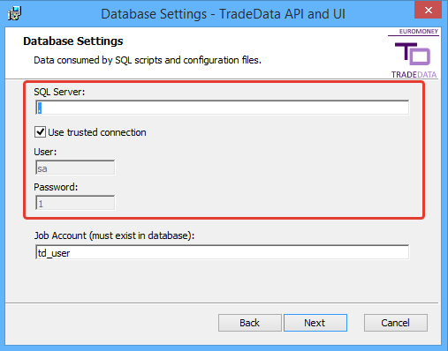

On IIS settings page provide correct API DNS, this will help to set up baseURL in the mentioned configuration file.

Same with this page – App Pool name required to create user in database, web service DNS is required for Simple Client config file.

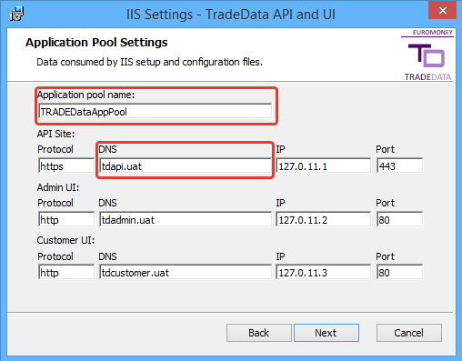

If database already exists it won’t be updated with user, whose name matches application pool name.  
To apply this, delete or rename existed database before running setup.

Hosts file will be updated during installation.  
Records are marked with comment " #Added by TDAPI setup".   
Records will remain in hosts file after uninstall.

You will have to deal with IE security settings after installation – add sites to trusted zone, etc.

## Uninstall

Everything will be removed except database.